Student Name:___________________________

Student Number: __________________
A

BUSINESS ADMINISTRATION


Introduction to Marketing
BUAD 116

Exam 3A KEY

Fall 2018

Professor: Michael Orwick

Time: 30 minutes

Part | Topic | Out Of | Score
1 | Multiple Choice | 12
2 | Mixed Answer | 12
3 | Short Answer | 10
Total |  | 34

Please read all instructions carefully!

Part 1 Multiple-choice Questions

Identify the choice that best completes the statement or answers the question. Mark your answers on the BUBBLE SHEET.

- 1 In the Product Life Cycle, which stage may include penetration pricing?
  - Introduction
  - Growth
  - Maturity
  - Decline
- 2 In the Product Life Cycle, which stage lasts the longest for most products?
  - Introduction
  - Growth
  - Maturity
  - Decline
- 3 In the Product Life Cycle, which stage sees an influx of competitors?
  - Introduction
  - Growth
  - Maturity
  - Decline
- 4 In the Product Life Cycle, which stage often uses mass marketing for products such as cereals and shampoos?
  - Introduction
  - Growth
  - Maturity
  - Decline
- 5 Which is/are ways in which a company may modify its product? (There may be more than one correct answer)
  - Reach into a new market
  - Re-style the packaging
  - Promote new uses for its product
  - Add a new flavour
  - All of these are correct

- 6 If you want your product to be considered prestigious, which distribution intensity should you avoid?
  - Intensive
  - Selective
  - Exclusive
  - Specialty
  - None of these is correct
- 7 Which is/are types of value offered by members of the marketing channel? (There may be more than one correct answer)
  - Time
  - Form
  - Place
  - Ownership
  - All of these are correct
- 8 Why would a company decrease the price of a mature product?
  - To modify its target market
  - To attract new competitors
  - To attract new distributors
  - To counter the competition
  - All of these are correct
- 9 What would it be called if a company bought 500 dresses from a manufacturer, sorted them into sizes and colours, then sold them to retailers in packages of 10-20 dresses at a time?
  - Rack jobbing
  - Streamlining
  - Breaking bulk
  - Disintermediation
  - None of these is correct
- 10 Who uses their own racks to sell specialty products (e.g., books, magazines, gift cards) in someone else’s store?
  - Pop-up stores
  - Drop shipper
  - Broker
  - Rack renters
  - None of these is correct

- 11 What is it called when a manufacturer offers discounts to a wholesaler?
  - Intensive distribution
  - Push strategy
  - Pull strategy
  - Promotional equniece
  - None of these is correct
- 12Which of the following is/are a problem you might face when outsourcing? (There may be more than one correct answer.)
  - Increase in in-house activity costs
  - Increase in offshore risk
  - Loss of quality control
  - Inability to protect your technology
  - All of these are correct

New Product Development Process
Actions | Step
Asking employees for improvements | 1
Weed out the weak ideas | 2
Brainstorming | 1
Estimate costs and demand | 4
Create a prototype | 5
Order production materials | 7
Begin drafting a marketing strategy | 5
Consider patents, sales, and competition | 2
Align the product with company objectives | 2
Concept tests | 3
Considering economic trends | 4
Finding a market that is isolated | 6
Building inventories | 7

Identify which Action (on the left) belongs in which Step in Process (on the right) by placing the number of the Step into the blank column next to the Action. (1/2 mark each)

Step in Process
1) Idea Generation
2) Idea Screening
3) Concept Development
4) Business Analysis
5) Product Development
6) Test Marketing
7) Commercialization

Part 2 – Product Life Cycle
Read the short case and answer the questions that follow.

Batamor Blinds makes high-end blinds for home and commercial use. Its products range from tough, industrial strength blinds for factories and corporations to elegant, breath-taking blinds for lavish homes. The company has been extremely successful in the 25 years it has been in business.

While sales are continuing to increase year over year, the rate of increase has slowed. At its peak, Batamor Blinds saw 20%-30% increases year to year. Now, for the past two years, the increase have been flat at about 4%.

Many consider Batamor Blinds to be the finest in the industry. Even the blinds that are not fancy in appearance are built using new technology that allows the highest standards and last much longer than any other in the market. Although there have been many competitors over the years, only a few have survived to this day.
- Draw a Product Life Cycle and show the usual profit line. Label it correctly. (4 points)

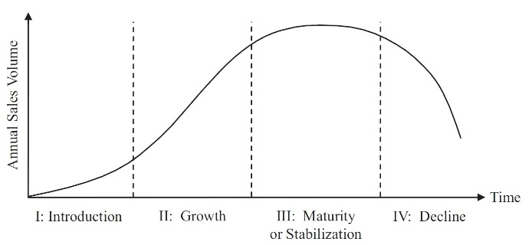

- Using an X, mark the product from the short case on the Product Life Cycle you have just drawn? (1 point) Below, explain why do you think it should be there? (2 points)

Since sales have started to slow down after large increases, but they are still slightly growing, it is likely near the top of the maturity stage.

- What type of pricing strategy would you recommend, and why? (3 points)

Competitive pricing would be most likely, since the company will have the maximum number of competitors in play at this time. It is also possible that the company may consider penetration pricing to increase or to maintain demand at this point.

