Preferred cannabis products
The Canadian Press - Jan 15, 2019 / 5:35 am | Story: 246779
Photo: The Canadian Press
A Tilray Inc. and Authentic Brands Group concept cannabis product is shown in this undated handout photo.
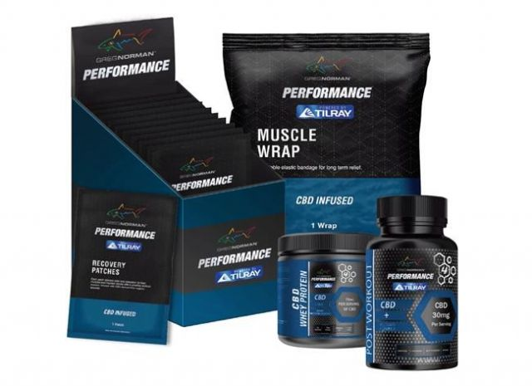
Licensed producer Tilray Inc. has teamed up with the U.S. company behind brands such as Juicy Couture, Aeropostale and Nine West to develop and sell co-branded consumer cannabis products globally, with items expected to hit U.S. and Canadian shelves within the next year.
The Nanaimo, B.C.-based company announced Tuesday the long-term revenue sharing agreement with Authentic Brands Group, to whom Tilray will initially pay US$100 million in cash and stock, or up to $250 million depending on certain milestones.
Tilray will receive up to 49 per cent of the net revenue from these products bearing names from ABG's portfolio of more than 50 brands, with a guaranteed minimum payment of up to US$10 million annually for 10 years.
"We believe that consumers will be much more likely to try a cannabis or CBD product if it's branded with a brand that they already know and trust," said Tilray's chief executive Brendan Kennedy.
Under the deal, Tilray would be the preferred supplier of active cannabinoid ingredients, such as CBD and THC, for ABG's cannabis products.
"We see extraordinary potential for cannabis in the fast-growing health and wellness category — particularly for CBD products in the United States and around the world — and are excited about this long-term partnership," said ABG's executive vice chairman Daniel Dienst in a statement.
While the two companies have not finalized which brands will be utilized, potential products include Nine West CBD foot cream or CBD-infused muscle wraps under the tennis brand Prince, with a logo that says "powered by Tilray." The deal with ABG does not limit Tilray from signing partnerships with companies in the cosmetic space, said Kennedy. He expects these co-branded products to be on the market within 12 months on both sides of the border, as allowed under U.S. and Canadian regulations.
The signing of the farm bill in the U.S. in December designated hemp as an agricultural crop and opened the door for widespread distribution of hemp-derived CBD products south of the border.
As such, their co-branded products south of the border will contain hemp-derived CBD, sourced from a farm in the U.S., said Kennedy.
In Canada, these consumer goods will include THC and CBD products sourced domestically, but how they will be distributed will depend on domestic regulations concerning edibles and topical products, he added.
"Imagine a CBD foot cream sample that was in every box of the one million pairs of shoes that they sell every year... and that introduces that consumer to this particular product," he said.
While dried flower and cannabis oils have been legal in Canada since Oct. 17, Ottawa only released proposed rules for edibles and topicals in December. The federal government is gathering public input on these draft rules until Feb. 20, and edibles will be legalized for sale no later than Oct. 17, 2019.
This is the latest partnership for Tilray, which last month announced a deal with the parent company of Labatt Breweries of Canada, Anheuser-Busch InBev, to research cannabis-infused drinks for the Canadian market.
The licensed producer last month signed a collaboration agreement with Sandoz AG, part of the Novartis pharmaceutical group, to work together to increase the availability of high quality medical products across the world.
While big tobacco and big alcohol have taken equity stakes in some of their competitors, such as alcohol giant Constellation Brands and Canopy Growth Corp., Tilray has opted to go the partnership route, Kennedy said.
"We preferred to control our own destiny... It's early days and we're not for sale."

