Names of participants: ________________________________________________________

_________________________________________________________

Consider the four characteristics of a service. Now, using one of the options below, explain just how those characteristics apply to that choice.

Bank

Hairdresser/Barber

Childcare

College

Doctor

Auto Repair Shop

Teacher

Tour Guide

Intangibility:
____________________________________________________________________________________________________________________________________________________________

Inseparability:
____________________________________________________________________________________________________________________________________________________________
Perishability:
____________________________________________________________________________________________________________________________________________________________
Variability (heterogeneous):
____________________________________________________________________________________________________________________________________________________________

How could these make their service seem more like a product to the customer?
__________________________________________________________________________________________________________________________________________________________________________________________________________________________________________

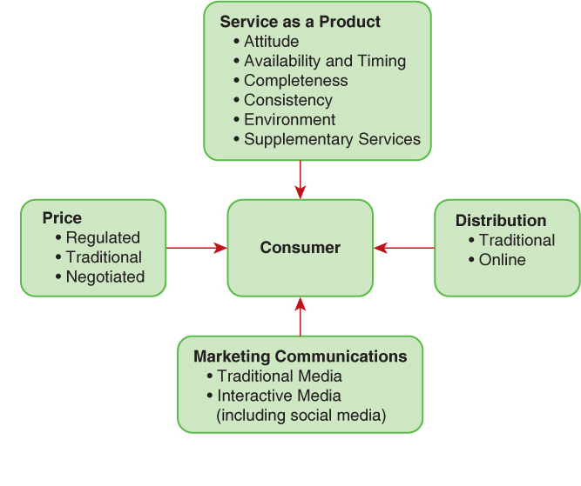
Describe the Service as a Product Characteristics

Characteristics of Distribution?

Characteristics of Marketing Communications?

Characteristics of Price?

